**Compiler vs Interpreter:**

Machine Language(Code) – Language that machine or computer understands

Soucrce Code – Code written by programmers.

** The translation from source code to machine code is done by Compiler. Compiler also performs some operations-

Compiler checks the Syntax

It optimizes our code

Generate Machine Code

Once Machine code is generated, it is executed very fast. Hence, Compilation is faster.

But since Machine code varies according to the OS and arch of the machine, hence it is not platform independent.

** Interpreter directly executes the Source code, therefore there is no Compilation step(converting to Machine code).

The interpreter executes the Program line by line, and it is slower.

Since you just need to give the source code to the interpreter, and it will give you the result, hence it is platform independent.

**What is JVM and how does it work?**

A Java virtual machine (JVM) is a virtual machine that enables a computer to run Java programs as well as programs written in other languages that are also compiled to Java bytecode.

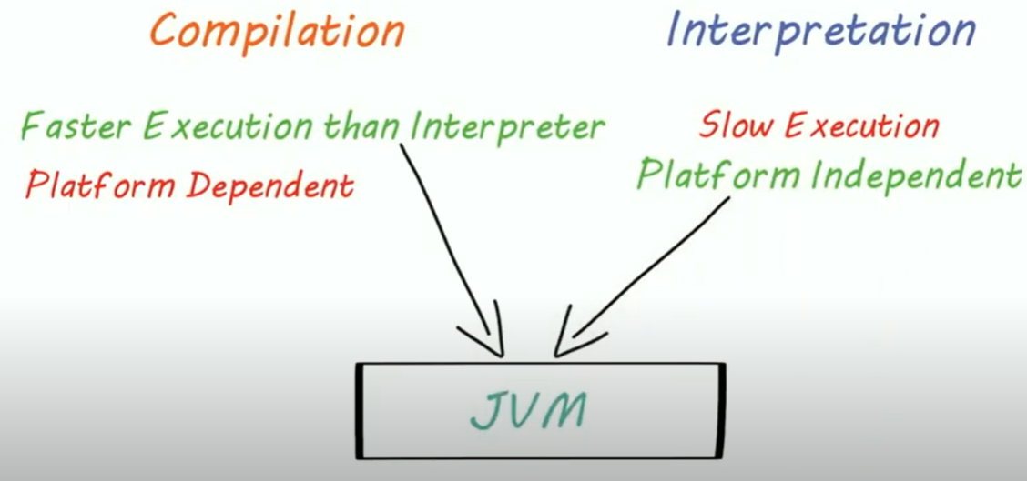

JVM uses the advantage of compilation and interpretation.

The JVM plays a central role in making Java portable. It provides a layer of abstraction between the compiled Java program and the underlying hardware platform and operating system. The JVM is central to Java's portability because compiled Java programs run on the JVM, independent of whatever may be underneath a particular JVM implementation.

Java programs are compiled into a form called Java bytecodes. The JVM executes Java bytecodes, so Java bytecodes can be thought of as the machine language of the JVM. The Java compiler reads Java language source (.java) files, translates the source into Java bytecodes, and places the bytecodes into class (.class) files. Which can be run on any platform.

**Inside JVM, there’s JIT(Just in time compiler), instead of interpreter which speeds up the execution.

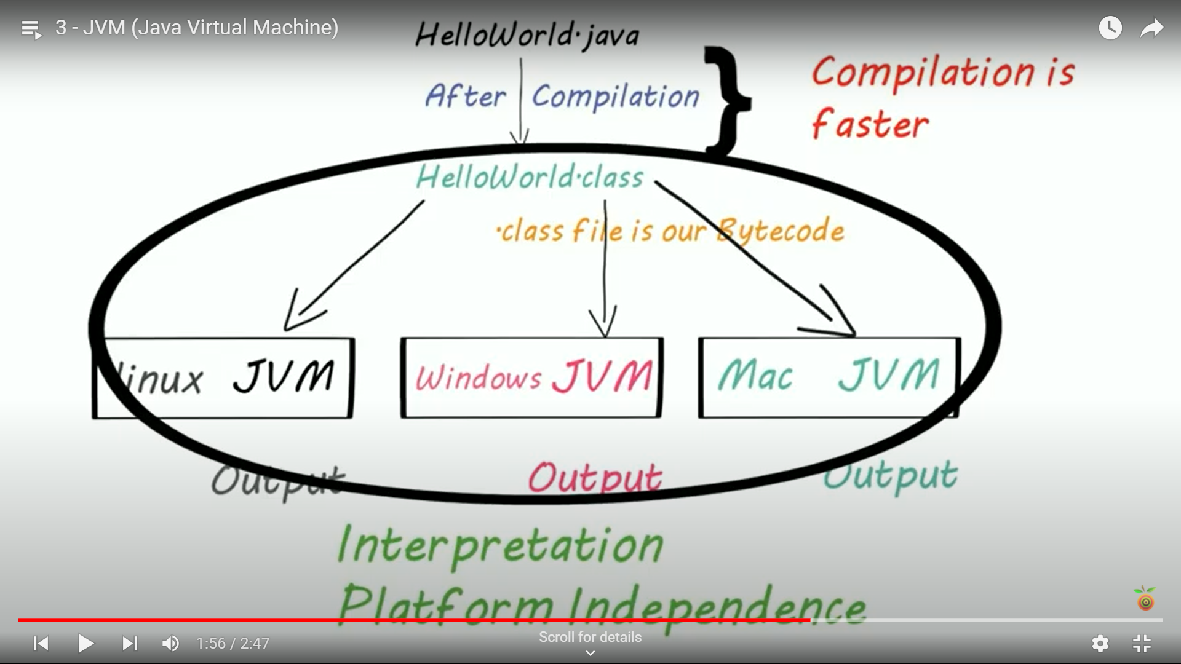W

**What is JRE**

A Java™ runtime environment (JRE) is a set of components to create and run a Java application. A JRE is part of a Java development kit (JDK). A JRE is made up of a Java virtual machine (JVM), Java class libraries, and the Java class loader.

**What is JDK**

Java Development Kit (JDK) is a software development environment used for developing Java applications and applets. It includes the Java Runtime Environment (JRE), an interpreter/loader (Java), a compiler (javac), an archiver (jar), a documentation generator (Javadoc), and other tools needed in Java development.

